**Co-production Evidence Log**

This document is for collecting information about a time you were listened to………

It is to evidence good practice and show when young people have been listened to across the area. Evidence will be shared via the local offer, governance boards and maybe used for the joint local area inspection.

**Summary of experience.** Please give a short overview of the time you were listened to. This is the important information that lets others know what happened.

C:\Users\ahoward\AppData\Local\Microsoft\Windows\INetCache\Content.Word\InPrint image.png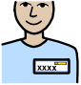

Details of listener

If you know them

Name Email Phone



What did you discuss?

**Happy?**

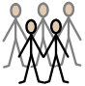

Others involved (numbers, age range, additional needs etc.)



What did they ask?



What you and/or other young people said?



Did anything change? What decisions have been made?

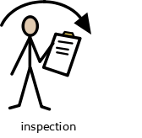

Has there been follow up?

No

Yes

How did this experience feel?

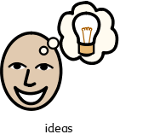

What important things have you learnt from this experience?

Your details!

Name

Age

Contact information

C:\Users\ahoward\AppData\Local\Microsoft\Windows\INetCache\Content.Word\InPrint image.png